Answer **A**:

1. According to the Cost matrix the best **classifier is A**

Explanation:

In Cost matrix the high value is 80, which comes when an actual NO predicted as YES. The chances of getting that error higher in **Classifier B (30).**

Negative value in a Cost matrix interrupted as benefits and positive values are benefits. Hence in the diagonal elements are the correct prediction, which gives the real benefits.

1. **Cohen’s kappa** is defined as:

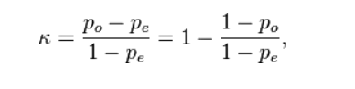

**Kappa Value of Classifier A**

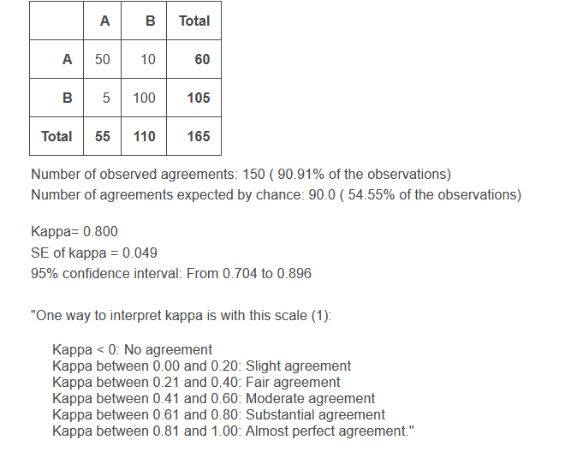

**Kappa Value of Classifier B**

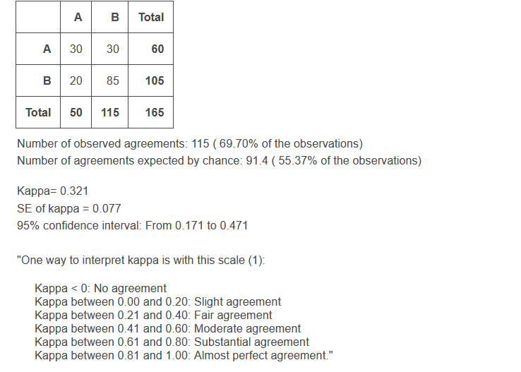

**According to Kappa Value Classifier A is the best classifier.**

1. **Classifier A**

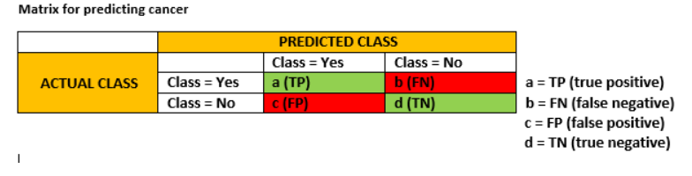

**Precision = a/ (a+c)**

**= 50 / (50+5)**

**=0.9090**

**Recall = (a)/(a+b)**

**=50 / (60)**

**=0.8333**

**F- Measure = 2a / (2a+b+c)**

**=100 / (100+10+5)**

**= 0.869**

**Classifier B**

**Precision = a/ (a+c)**

**= 30 / (30+20)**

**=0.60**

**Recall = (a)/(a+b)**

**=30 / (60)**

**=0.50**

**F- Measure = 2a / (2a+b+c)**

**=60 / (60+30+20)**

**= 0.545**

1. **Accuracy**

**Classifier A**

ACC = (a + d) / (P + N)

**Accuracy= 0.90**

**Classifier B**

**Accuracy = 0.69**

Answer **B:**

1. **Size of instances for the below attached data is 4**

i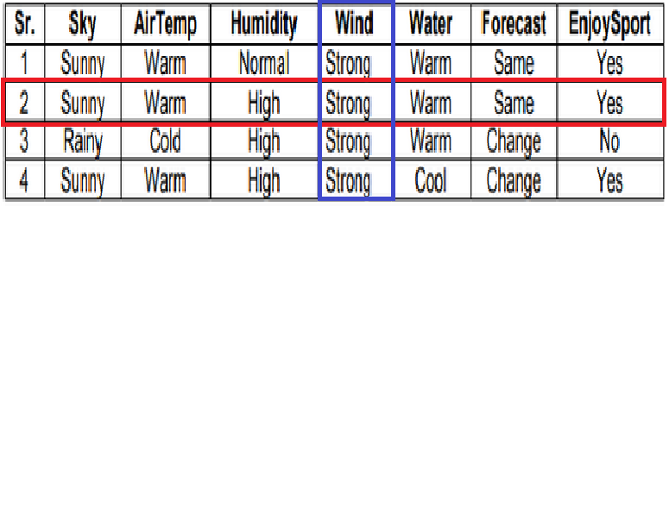

Marked in **RED is called instance.**

Marked **BLUE** is called Feature.

1. **Size of hypothesis size is 2**
2. **S algorithm**

h0 = {sunny,warm,normal,stron,warm,same}

h1 = {sunny,warm,high,strong,warm,same} - > {?,warm,?,strong,,warm,same}

h2 = {?,warm,?,Strong,?,?}

**h3 = {?,?,?,Strong,?,?} - > Final Hypothesis**

1. When adding an attribute (row) Waterflow, which is having 3 different values that will affect hypothesis spaces only. Number of instances will be changed once the column size changed.

**Size of hypothesis will be 3**